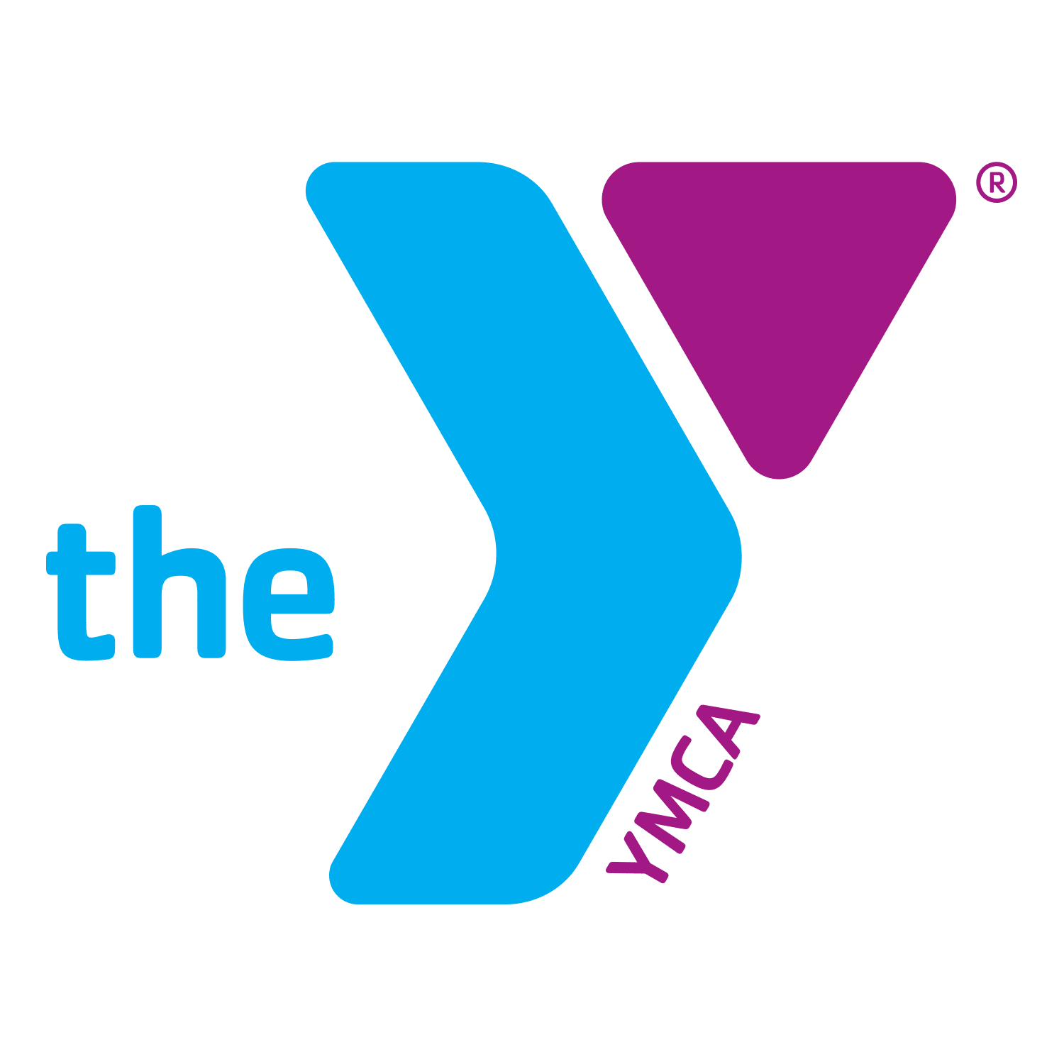 October 2020 Fitness Class Schedule
Monday | Tuesday | Wednesday | Thursday | Friday | Saturday
 |  |  | 1  Lower Body Blast with Derek 12PM  Spinning 6PM | 2  Spinning with Misty 5:30AM | 3  Piyo 8:30 AM- 9:15 AM  Zumba 9:15-10:00 AM
5  Spinning with Kay 5:30AM  Core de Force 6PM (ZOOM) | 6  Upper Body Blast w/ Derek 12PM  Live Fit 6PM  Zumba 6PM | 7  Spinning with Brett 5:30AM  Core de Force 6 PM (ZOOM) | 8  Lower Body Blast with Derek 12PM  Spinning 6PM | 9  Spinning with Misty 5:30AM | 10  Piyo 8:30 AM- 9:15 AM  Zumba 9:15-10:00 AM
12  Spinning with Kay 5:30AM  Core de Force 6PM (ZOOM) | 13  Upper Body Blast w/ Derek 12PM  Live Fit 6PM  Zumba 6P | 14  Spinning with Brett 5:30AM  Y-Fit with Derek 5:15PM  Core de Force 6 PM (ZOOM) | 15  Lower Body Blast with Derek 12PM  Spinning 6PM | 16  Spinning with Misty 5:30AM | 17  Piyo 8:30 AM- 9:15 AM  Zumba 9:15-10:00 AM
19  Spinning with Kay  5:30AM  Core de Force 6PM  Pickleball 5-8PM (ZOOM) | 20  Upper Body Blast w/ Derek 12PM  Live Fit 6PM  Zumba 6PM | 21  Spinning with Brett 5:30AM  Y-Fit with Derek 5:15PM  Core de Force 6 PM (ZOOM) | 22  Lower Body Blast with Derek 12PM  Spinning 6PM | 23  Spinning with Misty 5:30AM | 24  Piyo 8:30 AM- 9:15 AM  Zumba 9:15-10:00 AM
26  Spinning with Kay 5:30AM  Core de Force 6PM (ZOOM)  Pickleball 5-8PM | 27  Upper Body Blast w/ Derek 12PM  Live Fit 6PM  Zumba 6PM | 28  Spinning with Brett 5:30AM  Y-Fit with Derek 5:15PM  Core de Force 6 PM (ZOOM) | 29  Lower Body Blast with Derek 12PM  Spinning 6PM | 30  Spinning with Misty 5:30AM | 31  Piyo 8:30 AM- 9:15 AM  Zumba 9:15-10:00 AM

