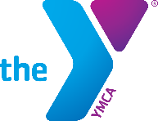
Y-Member Non-Member

The Richmond Family YMCA
Application Form- Cambridge City YMCA Y-Care

Child’s Name Sex______ Home Phone _________________ Last First Middle
Street Address City State Zip
Birth date Age E-Mail Address_______________________________________________
Attends Western Wayne Pre-School? If so, what days and times?
Parents(s) or Guardian(s) with whom child lives:
Father’s Name
Place of Employment Work Phone
Mother’s Name
Place of Employment Work Phone
Siblings: Name Age Name Age
Name Age Name Age

Parent/Guardian Signature Date

Please answer the questions below:

Are you a Sugar Creek Employee? _____

Are you a Western Wayne Employee? _____

Are you a YMCA member? _____

What type of care are you looking for?

Part Time Care (1-3): _____

Full Time Care (4-5 days per week): _____

Notice of Electronic Funds Transfer

An Electronic Funds Transfer Form (EFT) MUST be filled out to participate in the program. You will be invoiced Fridays according to your rate, and the withdrawal will happen on Mondays, unless in the case of a holiday. Then, it will be taken the next business day.

Child Care rates are on the attached page

*This is the application form only. Upon acceptance into Western Wayne Child Care, you would need to fill out the complete registration packet.

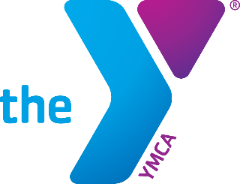

Cambridge City YMCA Y-Care
Full Time Preliminary Weekly Rates
(June 2020)

 | Sugar Creek*  Employees | Community
Infants (6 wks. – 1 yr.) | $120.00 | $130.00
Toddlers | $115.00 | $120.00
PreK(3 to 5) | $110.00 | $115.00

 | Sugar Creek Employees | Community
Registration Fee  (one time) | None | $20 (per family)
Family Discount | 15% on least expensive child | 15% on least expensive child

*Special pricing may apply for Western Wayne School Corporation employees

Financial Assistance for Families:
Child Care Voucher Fund (CCDF) Assistance is available through the State of Indiana. The YMCA staff will connect families to the State Agency for assistance.
YMCA Scholarship assistance may be available for those who do not qualify for the CCDF assistance program by completing a Scholarship Assistance Application.

