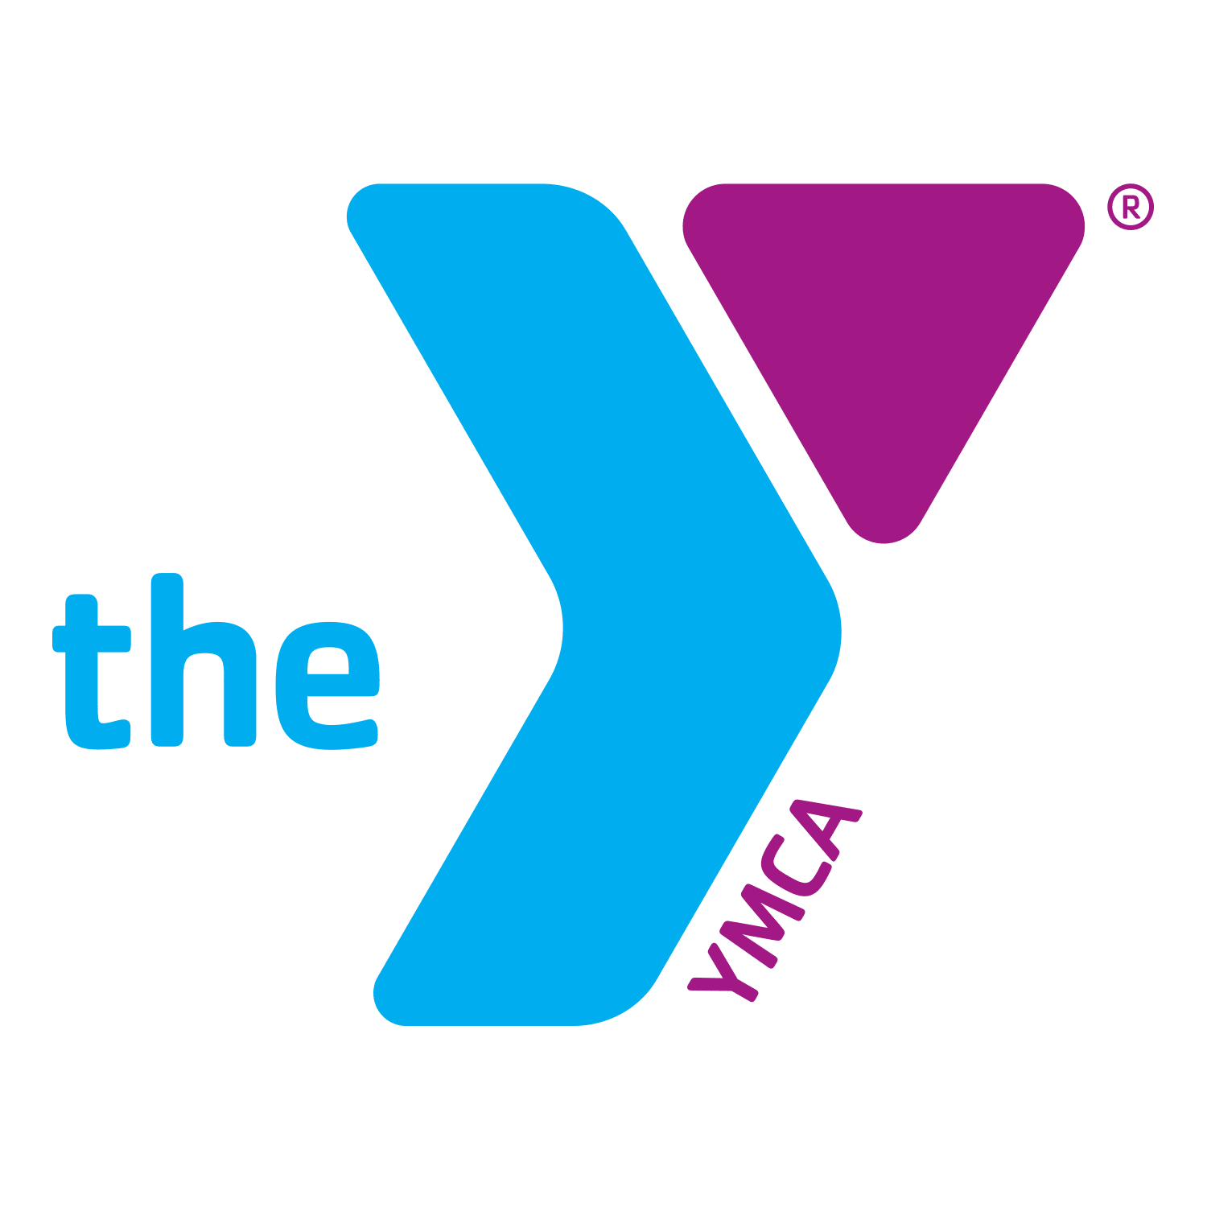 November 2020 Fitness Class Schedule
Monday | Tuesday | Wednesday | Thursday | Friday | Saturday
2  Spinning with Kay 5:30AM  Core de Force 6PM (ZOOM) | 3  Upper Body Blast w/ Derek 12PM  Live Fit 6PM  Zumba 6PM | 4  Spinning with Brett 5:30AM  Core de Force 6 PM (ZOOM) | 5  Lower Body Blast with Derek 12PM  Spinning 6PM | 6  Spinning 5:30AM | 7  Piyo 8:30 AM- 9:15 AM  Zumba 9:15-10:00 AM
9  Spinning with Kay 5:30AM  Core de Force 6PM (ZOOM) | 10  Upper Body Blast w/ Derek 12PM  Live Fit 6PM  Zumba 6PM | 11  Spinning with Brett 5:30AM  Core de Force 6 PM (ZOOM) | 12  Lower Body Blast with Derek 12PM  Spinning 6PM | 13  Spinning 5:30AM | 14  Piyo 8:30 AM- 9:15 AM  Zumba 9:15-10:00 AM
16  Spinning with Kay 5:30AM  Core de Force 6PM (ZOOM) | 17  Upper Body Blast w/ Derek 12PM  Live Fit 6PM  Zumba 6PM | 18  Spinning with Brett 5:30AM  Y-Fit with Derek 5:15PM  Core de Force 6 PM (ZOOM) | 19  Lower Body Blast with Derek 12PM  Spinning 6PM | 20  Spinning 5:30AM | 21  Piyo 8:30 AM- 9:15 AM  Zumba 9:15-10:00 AM
23  Spinning with Kay  5:30AM  Core de Force 6PM  Pickleball 5-8PM (ZOOM) | 24  Upper Body Blast w/ Derek 12PM  Live Fit 6PM  Zumba 6PM | 25  Spinning with Brett 5:30AM  Y-Fit with Derek 5:15PM  Core de Force 6 PM (ZOOM) | 26  Lower Body Blast with Derek 12PM  Spinning 6PM | 27  Spinning 5:30AM | 28  Piyo 8:30 AM- 9:15 AM  Zumba 9:15-10:00 AM
30
Spinning with Kay 5:30AM

Core de Force 6PM (ZOOM)

Pickleball 5-8PM

